Pizza Sales SQL Report

- KPIs

- Total Revenue
select sum(total_price) as Total_Revenue from pizza_sales;
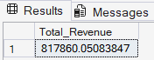
- Average Order Value
select (sum(total_price)/count(distinct order_id)) as Average_order_value
from pizza_sales;

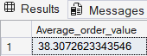
- Total Pizzas Sold
select sum(quantity) as total_pizza_sold from pizza_sales;
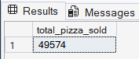
- Total Orders
select count(order_id) as total_orders from pizza_sales;
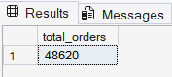

- Average Pizzas per Order
select cast((cast(sum(quantity) as decimal (10,2))/cast(count(distinct order_id) as decimal(10,2)))as decimal(10,2)) as average_pizzas_per_order from pizza_sales;
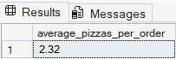

- Chart Requirements
- Daily Trend for Total Orders
select datename(DW,order_date) as order_day, count(distinct order_id) as order_count from pizza_sales
group by datename(DW,order_date) order by count(distinct order_id) desc;
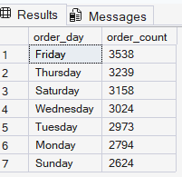
- Monthly Trend for Total Orders
select datename(MONTH,order_date) as month_name, count(distinct order_id) as order_count from pizza_sales
group by datename(MONTH,order_date) order by count(distinct order_id) desc;

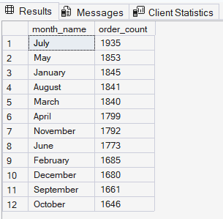
- Percentage of sales by Pizza Category

select pizza_category, cast( sum(total_price)*100/ (select sum(total_price)
from pizza_sales)as decimal(10,2))as percentage_of_sales from pizza_sales group by pizza_category;
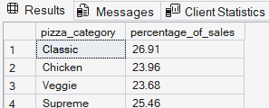
- Percentage of sales by Pizza Price
select pizza_size, cast( sum(total_price)*100/ (select sum(total_price)
from pizza_sales)as decimal(10,2))as percentage_of_sales from pizza_sales group by pizza_size;

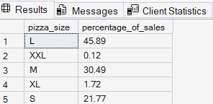

- Total Pizza Sold by Pizza Category
select pizza_category, count(quantity) as total_pizzas_sold from pizza_sales
group by pizza_category;
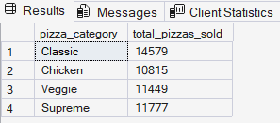
- Top 5 Best Sellers by Revenue, Total Quantity and Total Orders
select top 5
pizza_name,
sum(total_price) as total_revenue,
sum(quantity) as total_quantity,
count(distinct order_id) as total_order
from pizza_sales group by pizza_name order by total_revenue desc;

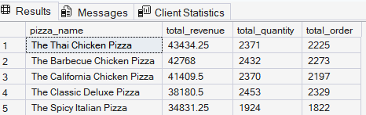
select top 5
pizza_name,
sum(total_price) as total_revenue,
sum(quantity) as total_quantity,
count(distinct order_id) as total_order
from pizza_sales group by pizza_name order by total_quantity desc;

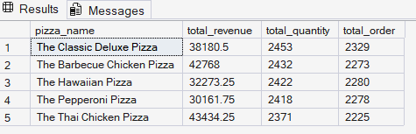
select top 5
pizza_name,
sum(total_price) as total_revenue,
sum(quantity) as total_quantity,
count(distinct order_id) as total_order
from pizza_sales group by pizza_name order by total_order desc;
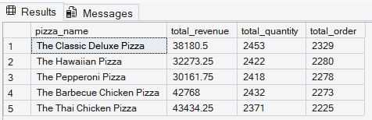

- Bottom 5 Best Sellers by Revenue, Total Quantity and Total Orders

select top 5
pizza_name,
sum(total_price) as total_revenue,
sum(quantity) as total_quantity,
count(distinct order_id) as total_order
from pizza_sales group by pizza_name order by total_revenue asc;
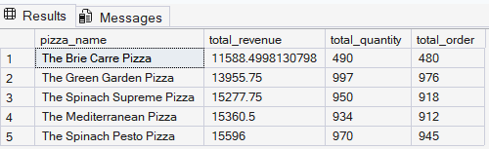
select top 5
pizza_name,
sum(total_price) as total_revenue,
sum(quantity) as total_quantity,
count(distinct order_id) as total_order
from pizza_sales group by pizza_name order by total_quantity asc;
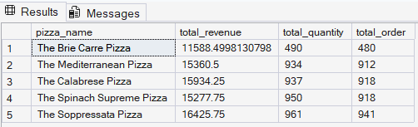
select top 5
pizza_name,
sum(total_price) as total_revenue,
sum(quantity) as total_quantity,
count(distinct order_id) as total_order
from pizza_sales group by pizza_name order by total_order asc;

